Further investigation need to be

1. Table ‘agency’ and ‘agency_address’.

ACH daily will use table ‘agency’ see class ‘Ach_Daily’

Not find anything about ‘agency-address’,Also it is no data in table ‘agency-address’

1. Table ‘attend_sum_status’.

Have foreign key for table ‘attendance summary’, they are using

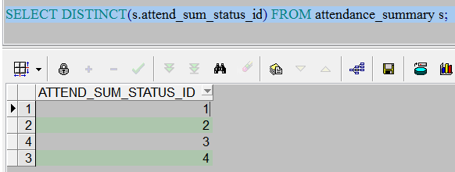

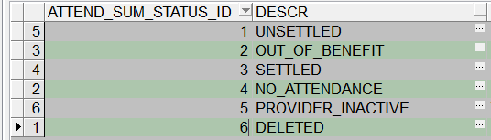

I think we should keep this table.

1. Table ‘embosser’.

I think this is card printers information; this page can disable/enable **Embosser and add new embosser.**

But I don’t know how to access the page; I don’t know it under which menu.I just found the url in xml config file.

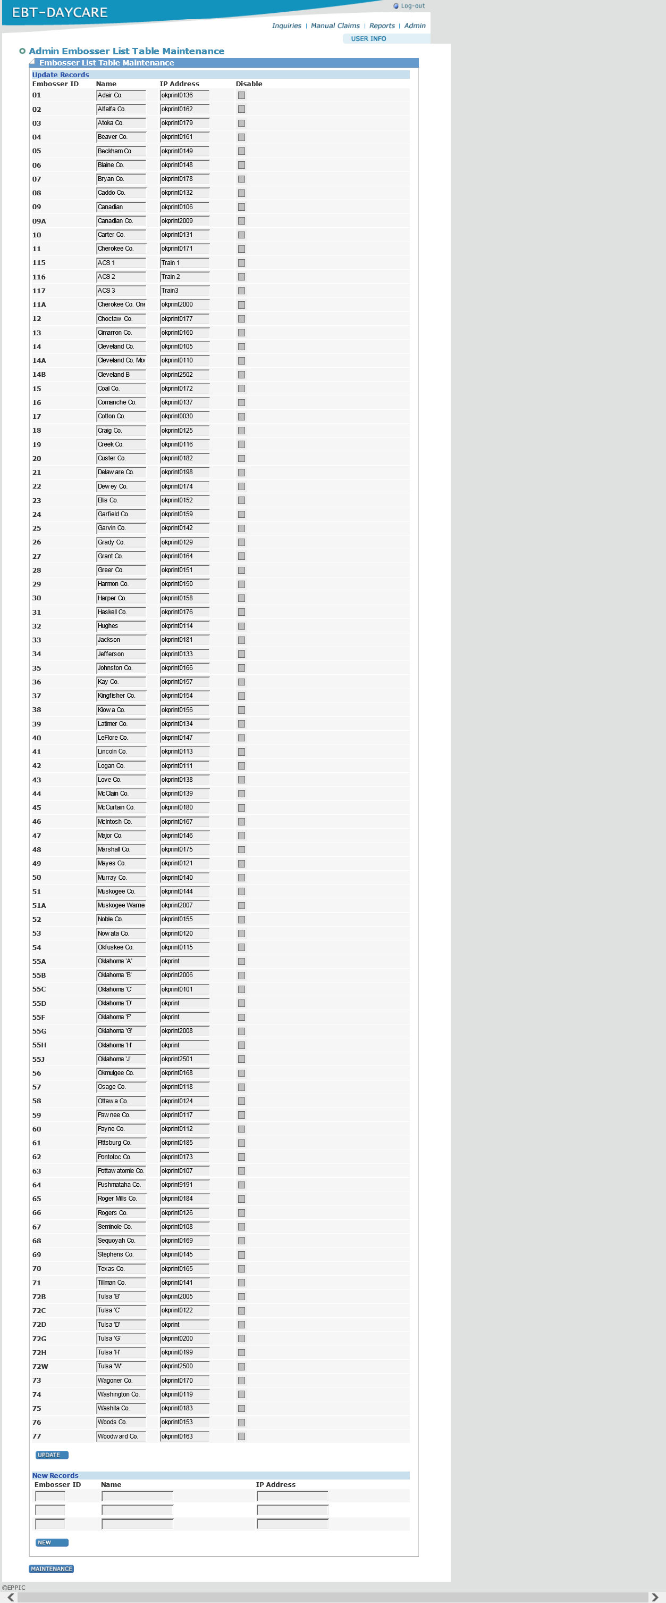

1. Table ‘office’ and ‘Office_Geography’

Seems office is only used in create user

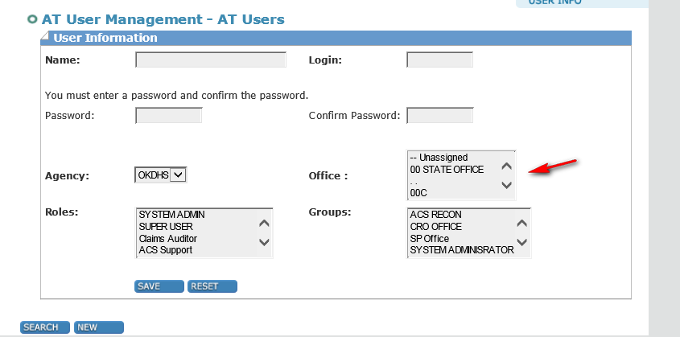

I can’t find anything about ‘office-geography’, maybe it is useless. Also it is no data in table ‘office-geography’

1. Table ‘ownership_type’

Has reference with table provider on column ‘ownershiptypeid’, but all provider data is using ownershiptype 1. Seems it is useless but only have a foreign key constraint.

1. Table ‘validation’, ‘validation_status’

Used in class ‘OKAchProviderPaymentsCmd’ will call validationfolderimpl

See line 769 method: addValidationMsg.

Also I found there is existing screen named ‘skip auth report’:

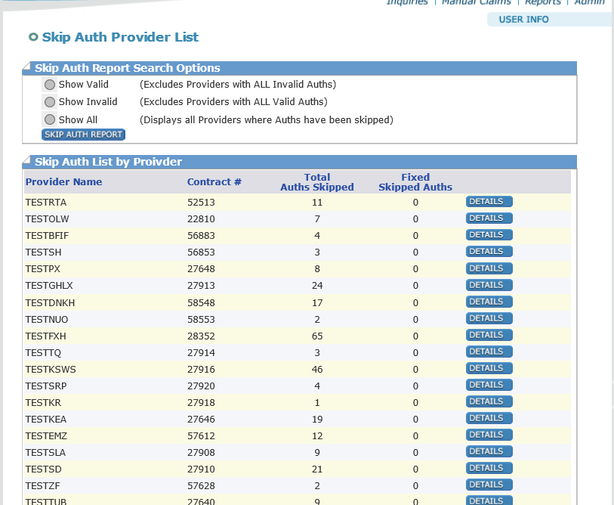

After click details button

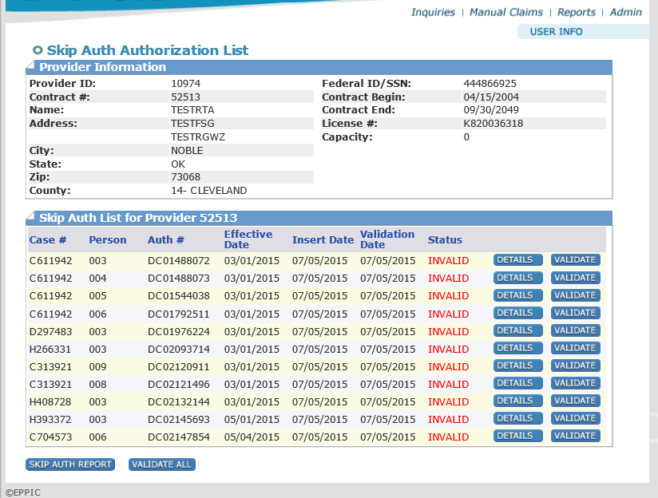

After click details button

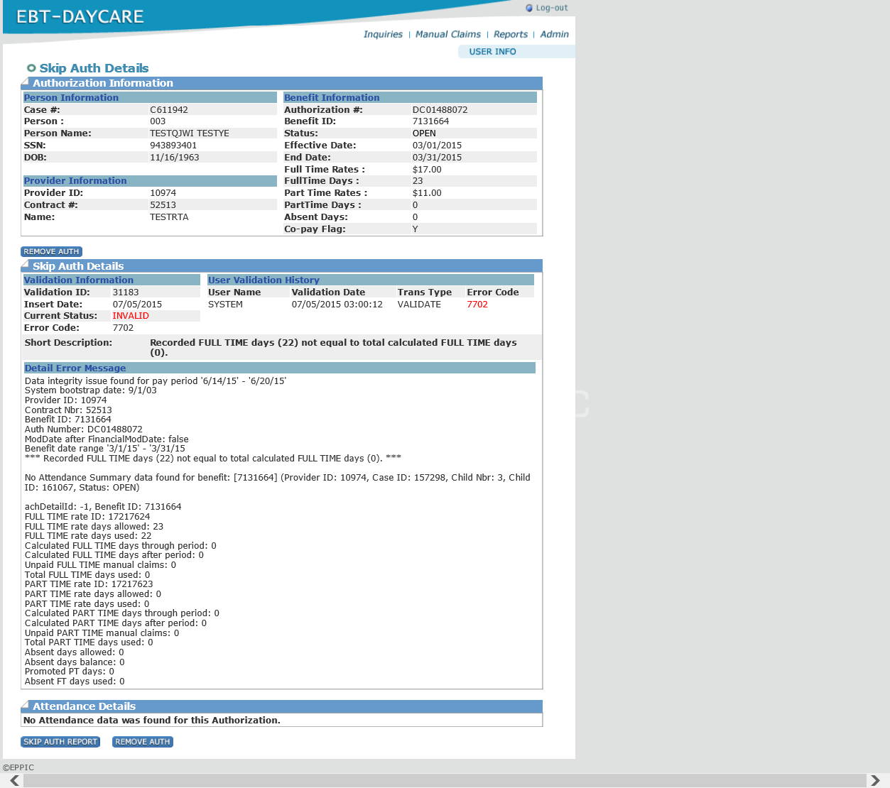

I think we should keep this table. Need to more discuss because it is related with payment process.

1. Table ‘benefit’